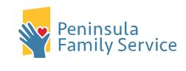
Peninsula Family Service Resource Line (PFS)
650-780-7542
Available M-F 7:30 am – 4 pm
- Housing Assistance
- Food Services
- Transportation
- COVID Information & Testing
- Referral to a Peer Counselor
- Information about Community Groups and Virtual Gatherings
  - Services and Resources in Other Languages

Additional Older Adult Services - Peninsula Family Service
- 650-403-4300
- Peer Counseling
- Fair Oaks Adult Activity Center
- Help@Hand – Technology Education and Workshops
- You Talk, We Listen – Counseling
- 650-403-4300 ext 4389 for more information
- $15 co-pay per visit

